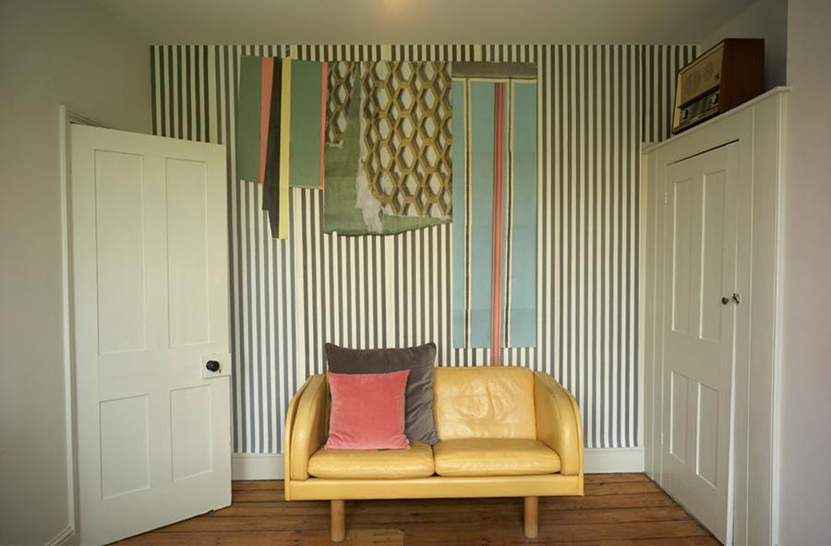

‘Wallpaper Collage’, a different way of decorating.
A NEW collection of 'Wallpaper Collage' designed and made by Deborah Bowness will be launched 19 May at ICFF, New York. The collection title aptly describes both the technique of applying the wallpapers and the resulting artworks made from the assemblage of different wallpaper pieces.
The nine brightly coloured, attention grabbing patterns of this collection are interchangeable componants of unique ‘Wallpaper Collage'. Spots and Stripes
are central to the theme, along with a loud two-tone colour pallet. This is a versatile collection with predesigned, create your own and made-to-measure wallpaper collage options available.
This year Deborah celebrates 20 years of designing, making and exhibiting wallpaper. The ‘Wallpaper Collage’ collection with its clashing colours and haphazard arrangements marks yet another confident step away from the conventions of wallpaper design and once again question the way in which we decorate our walls.

See the NEW Collection HERE
Download New collection info & spec sheets HERE (use password: ICFFpresspass )
Loan wallpaper office@deborahbowness.com
Visit Stand 1145 ICFF, 19 - 22 May 2019, Jacob K Javits Convention Centre, New York.

